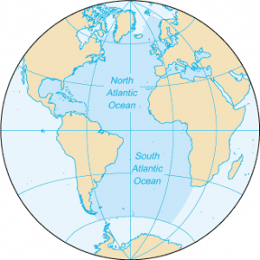

atlanticocean.png

second-largest and saltiest ocean in the world

The Atlantic Ocean is one of the world's major oceans and is known for its vast expanse, diverse ecosystems, and historical significance. The Atlantic Ocean is the second-largest of the world's five major oceans, covering an area of approximately 106.4 million square kilometers (41.1 million square miles).

the example of marine life in atlantic ocean

1. Bottlenose Dolphins

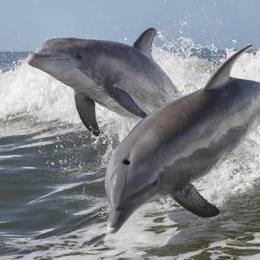

bottlenosedolphins_creaturesinatlanticocean.png

1. atlantic bluefin tuna

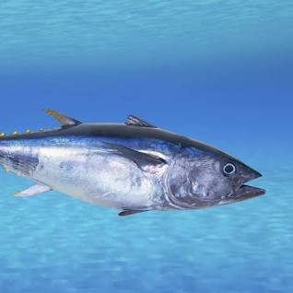

atlanticbluefintuna_creaturesinatlanticocean.png

1. great white shark

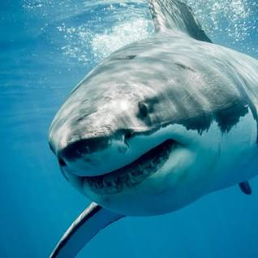

greatwhiteshark_creaturesinatlanticocean.png